|  |
| --- |
| **Members of the committee are asked to:**   1. **Note the contents of the report** |

The staff and volunteers at Healthwatch Gateshead have focussed on two key priorities during 2017/18; carers’ assessments and NHS continuing health care.

The carers’ assessment research was completed during the summer of 2017 and the final report has recently been shared with key stakeholders and the public. We hope that the outcomes and recommendations from our work will be reflected in the carers’ support service specification that Gateshead Borough Council is due to publish shortly.

Our research into NHS continuing health care is progressing well. The information gathering phase is now complete and Kim Newton, Project Manager, is now analysing the information and writing the final report. This will be published in the spring.

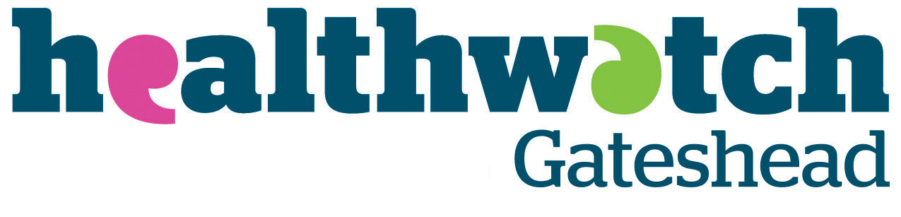

# 

**Caring for carers**

**Carer’s assessments in Gateshead**

**About Healthwatch Gateshead**

Healthwatch Gateshead is one of 152 local Healthwatch organisations established throughout England on 1 April 2013 under the provisions of the Health and Social Care Act 2012. We have a dual role to champion the rights of users of publicly funded health and social care services for both adults and children, and to hold the system to account for how well it engages with the public.

We collect feedback on services from people of all ages and from all communities. We do this through our network of voluntary and community sector organisations, during events, drop-in sessions and listening events at a range of venues across Gateshead, online through the feedback centre on our website, via social media and from callers to our information and signposting helpline. As part of the remit to gather views, we also have the power to ‘enter and view’ services and conduct announced and unannounced visits.

Healthwatch Gateshead is part of Tell Us North CIC (company no. 1039496).

Author: Healthwatch Gateshead

Publication date: January 2018

© Tell Us North 2018

**Contents**

Executive summary 1

Carers across the UK 1

Purpose of our review 2

What we did 4

Our findings 6

Summary of key findings 13

Recommendations 15

Acknowledgements 15

Appendix 16

Contact details 21

# Executive summary

Healthwatch Gateshead has gathered the views and experiences of carers on carer’s assessments in Gateshead in order to provide evidence for providers and commissioners to improve access and service provision.

We asked carers of any age in the Gateshead local authority area to complete a survey — 264 people participated, 56 of whom had experience of carer’s assessments. The surveys were conducted over a five week period, between July and August 2017.

We found that, overall, carers who had an assessment were glad they did so. However, feedback was broadly negative and included comments about the process for requesting a carer’s assessment not being user friendly and ‘fit for purpose’. There were twice as many negative responses than positive around people feeling that a carer’s assessment had helped them get the support they needed. Also, many carers did not know that assessments were available, nor what services were available to them.

It is clear from our research that a number of carer’s assessment procedures could be improved. Service users made a number of suggestions, resulting in recommendations in three areas:

1. Increase uptake of assessments
2. Improve assessment quality
3. Streamline partnership working

Further details can be read in the recommendations section of this report.

# Carers across the UK

A caring responsibility comes at a cost to the carer and it is now recognised that carers need help to make sure they have both the capacity to manage to care and the support to protect their own health and wellbeing. Both social care and health services rely heavily on carers committing to provide care and support for someone with care needs as part of care management:

* Three in five people will be carers at some point in their lives in the UK
* There are currently around seven million carers in the UK, equating to approximately one in ten people, and the numbers continue to rise
* In the UK, 42% of carers are men and 58% are women
* The economic value of the contribution made by carers is £132 billion a year
* By 2030, the number of carers will increase by 3.4 million (around 60%)
* Carers’ contribution would cost the government an additional £119 billion if it was not there (Carers UK 2010)

**What is in a carer’s assessment?**

The Care Act 2014 introduced important new rights for carers. Carers now have the right to a free assessment of their needs and to receive support. Before the Act, only carers who provided ‘substantial’ and ‘regular’ care were entitled to an assessment.

The amount of care provided or financial resources do not affect carer’s rights ― the important factor is the impact that caring may have on an individual’s daily life and wellbeing. If a carer has previously been refused an assessment because they did not meet the eligibility criteria, another assessment can be requested. A carer’s right to assessment is not dependent on the person being cared for: they are entitled to an assessment even if the person being cared for refuses an assessment of their own needs.

The Care Act 2014 also states that an assessment must take into account the needs of the whole family. If everyone is in agreement, assessments for the carer and the person they are caring for can be carried out at the same time. However, a carer can request an individual meeting.

# Purpose of our review

Carer’s assessments identify the help an individual may need to care for someone, as well as looking at how better support for informal carers can be put in place, regardless of the age or the condition of the cared for person.

**Profile of Gateshead**

**Gateshead has a population of 200,214**

**There are 22,220 carers (based on the 2011 Census); the majority are aged between 25—64 years (approximately 58% are female and 42% male)**

**Thirty eight per cent of the population of Gateshead live in the 20% most deprived areas of England**

We made carer’s assessments one of our research priority areas for 2017―18. Carers had told us about the issues they were experiencing, including trying to access services, obtaining a carer’s assessment or receiving the support identified when assessed.

Newcastle Gateshead Clinical Commissioning Group (CCG) and Gateshead Council have also reviewed their support services for carers. They met with carers of all ages, and with provider organisations and health and social care professionals, to ask about the role of informal carers. Feedback showed that carer’s assessments were a very important part of supporting carers.

However, recent engagement by the council and the CCG (conducted by Involve NE) did not look at carers’ experiences of the assessment. Also, a recent carers’ survey by Gateshead Carers Association touched on assessment but not the experience of conducting one, or the barriers to uptake.

There has been a low uptake of assessment requests in Gateshead and the numbers are dropping each year. This is despite supporting evidence identifying that the need for carer support is clearly increasing.

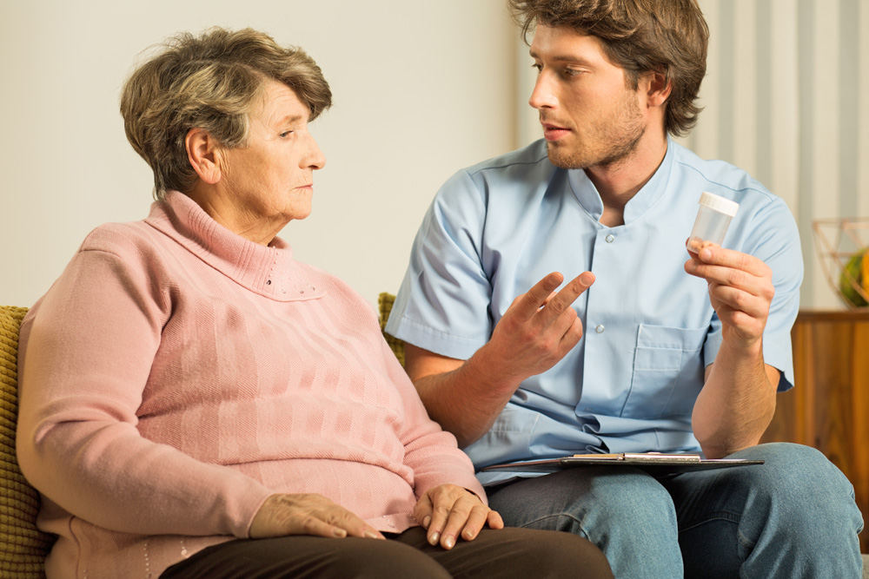

Healthwatch Gateshead acts as an independent voice (other reports are from stakeholders) and our research provides a service user perspective as to why there is a low assessment uptake.

Providers and commissioners recognise a need to improve on assessment uptake. A new commissioning model proposes to tender out carer’s assessments; therefore feedback on the present process and service user experience will be useful in informing the new monitoring framework.

By examining the barriers to assessments taking place, and providing feedback on the present process and service user experience, we hope to have a positive impact on the quality and quantity of carer’s assessments in Gateshead. Our research may also help to improve end to end processes around carer’s assessments (including information sharing, the assessment, post assessment follow-up and perceived impact) so that support is better tailored to an individual carer’s needs.

# What we did

With the help of carers’ organisations in Gateshead we developed a survey for carers (see appendix). The aim was to gather their experiences of assessments in Gateshead and to provide evidence for providers and commissioners in order to improve access and service provision.

The survey was sent out with a covering letter to individuals and groups in Gateshead via Carers Trust Tyne and Wear, Gateshead Older People’s Assembly, adult social care services, Age UK, and the Queen Elizabeth Hospital community care team. The survey was advertised in the Healthwatch Gateshead newsletter, with contact details for those who wanted further information or help in completing the survey, or who required a paper version of the survey. We also used paid promotion on social media to help us reach as many Gateshead residents as possible.

The council, CCG and voluntary and community sector organisations, such as Age UK Gateshead and Alzheimer’s Association, also promoted and encouraged people to complete the surveys. The Carers Trust promoted the survey on Facebook, Twitter and its website, with a request for carers to take part in telephone or face to face interviews. The Stroke Association sent out surveys via email and post, as well as publicising on its website. The Queen Elizabeth Hospital community care team distributed surveys out in the community.

The survey was conducted over a five week period in July and August 2017. This was a shorter time than we would normally aim for (particularly over a holiday period) however, it was done to fit in with CCG and council review timescales. Carers of any age in the Gateshead local authority area were invited to take part.

**Who responded?**

In total, there were 264 valid responses which was a large number considering the limited time available. Not every respondent answered every question; this was particularly the case for the demographic questions.

Over two thirds of respondents were between the ages of 25 years and 64 years. There was a low response from people aged 17 and under and from 18—24 year olds. Because the work was completed during the school summer holiday this may have been a factor in the under representation of young people. Research also shows that there are many hidden young carers who may not see themselves in a caring role or who do not wish to speak out due to fear of being labelled.

The vast majority of respondents described their ethnicity as white British. Five respondents preferred not to say and the remaining nine stated they were Asian or Asian British, Arab, Irish or from other ethnic groups.

# Our findings

When asked “Have you had a carer’s assessment in Gateshead?” 180 replied ‘no’, 56 said they had taken part in an assessment and 26 did not know. Many carers did not know about carer’s assessments and what services are available.

We asked carers who had not had an assessment to tell us if they had any other comments they wished to share. Some responses included:

**“How is the average carer supposed to find out about carer’s assessments? No-one tells you anything, I've had a social worker for years and it’s not been mentioned. There needs to be an awareness campaign which they won’t have as it'll cost money which they don't have.”**

**“Don’t know anything about carer’s assessments.”**

**“Better understanding and knowledge to be available as to how the carer’s assessment will help my caring responsibility as I'm more under the impression that it's to identify carers for government statistics than to actually help.”**

**“There are a lot of people who just get on and manage, with very little or no help whatsoever. It can be very difficult and hard to know where to go.”**

**“My needs aren't assessed, they only assess the needs of my disabled son whom is under 16.”**

**“I am on the waiting list, but not told how long the waiting will be. I got the impression that the system is overwhelmed. I got the impression that I won’t be prioritised as I seem to be coping.”**

When asked why a carer had not had an assessment the vast majority (half of respondents) did not know about them. A similar number stated that Gateshead Council had not offered them an assessment.

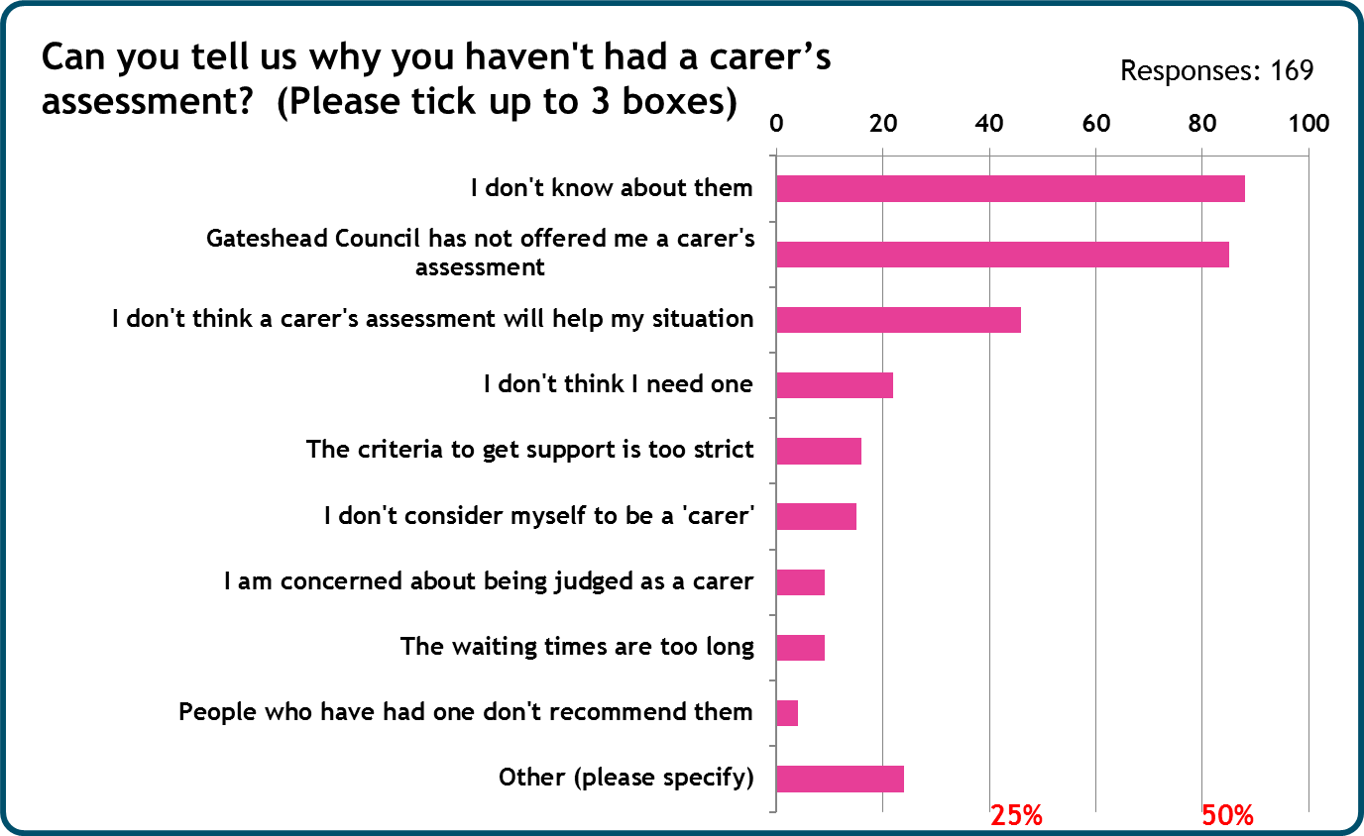

More than three quarters of respondents wanted to receive more information about what a carer’s assessment was and how it could help them. More than half of respondents wanted more information on specific support and services available to carers.

The third and fourth most common answers were that people assumed they either did not need an assessment or that it would not help them in any way. As can be seen from the graph on page 8, the majority of people wanted more information about the assessment before proceeding.

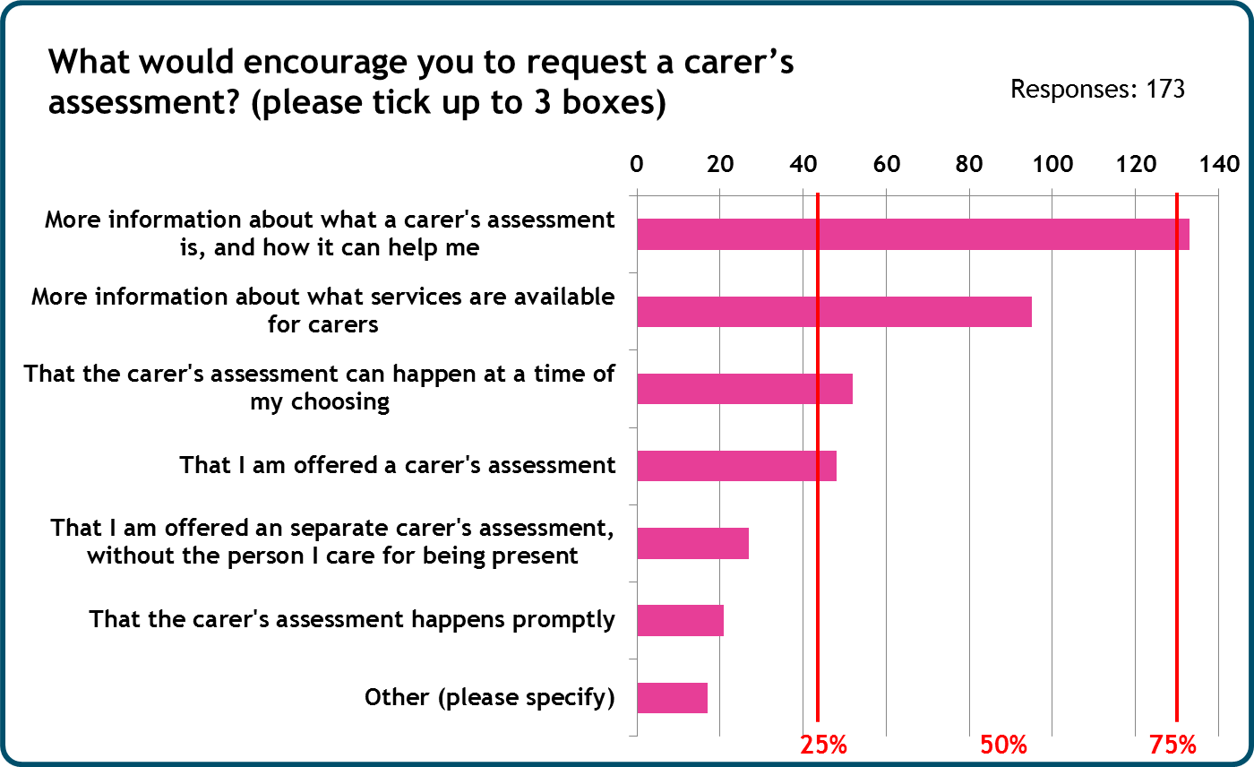

Of the people who had received a carer’s assessment (56 in total), 20 requested an assessment directly, 24 were offered one and eight did not know how they had found out about it.

We asked them how they would rate the service they received. Overall the responses were negative:

**“I actually work in the care industry and I don’t always know what is available and from where. Support is inconsistent and it’s not always clear who provides what. This needs explaining as I don’t know what a carer’s assessment aims to achieve. Carers have limited time/energy to be phoning around. Once I called Adult Social Care Direct — took 20-30 minutes to speak to a human being!”**

**“The person on the phone spoke quickly with a list of choices which I found difficult to take in. When I asked how long it would be before someone contacted me the person said weeks rather than days. He showed no real interest or concern. I put in a complaint — maybe that's why things moved more quickly.”**

**“I was given false hope.”**

**“Took quite a while for someone to come out.”**

Most carers heard about the assessment process from voluntary and community sector organisations or from friends and family members and their own research. Only 32.7% of respondents heard about carer’s assessments from health or care professionals (for example, social workers, GPs and care workers). Health and care professionals, such as social workers, GPs and Occupational Therapists, should consider how to publicise the assessments.

Of the 35 respondents to the question about rating their assessment experience (see the graph on page 10) there was a mixed response. The majority remained neutral or felt the experience was good and 12 respondents stated that the experience was either very poor or very good.

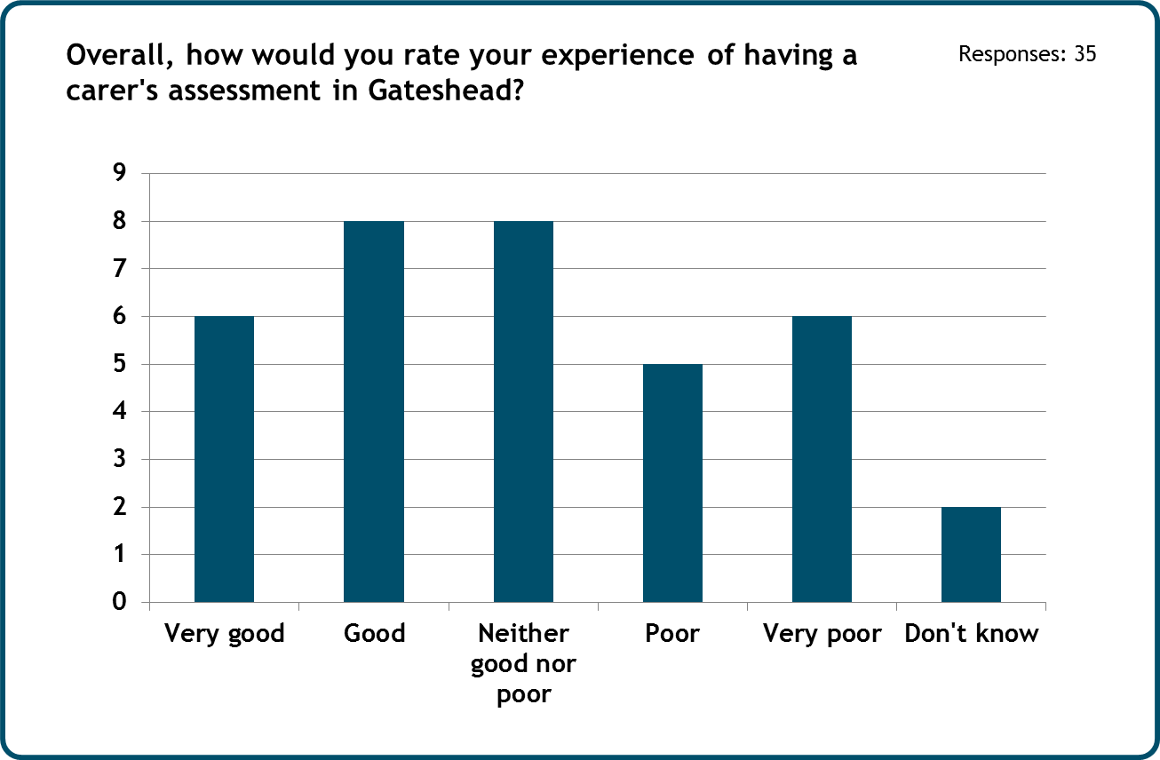

When asked if having a carer’s assessment had helped them get the support they needed there was a mixed response, with ten positive replies, ten neutral responses and 11 responding in a negative manner.

Comments included:

**“I was made aware of help that I wouldn't have known about.”**

**“I know there is support for me especially, when things get bad.”**

**“Pointless waste of my valuable time, it took time away from my caring role and didn’t lead to any meaningful help.”**

**“Was provided with a pile of paperwork by the social worker with no explanation about what is a carer’s assessment, or what services are available. I was offered some domestic support verbally but there was no choice in where the help came from, nothing explained.”**

Many respondents had positive comments about the support from both Gateshead Council and partner organisations:

**Gateshead Council**

**“I think social services have been very helpful in making caring for my daughter as stress free as possible and came up with the best plan for that time (3+ years ago). However with the passing of time, perhaps our care plan could be revisited to determine a long term plan.”**

**“I appreciate the two hours per week domestic support.”**

**“Providing sympathetic and practical help to allow me to continue caring for my daughter.”**

**“I didn't feel I needed a lot of support but I still thought the discussion was worthwhile and I know where to go if I find I do need more.”**

**Partner organisations**

**“Carers Trust was amazing — they helped me and are still helping me with my caring needs.”**

**“Gateshead Crossroads have been brilliant.”**

**“I have had very good contact with Gateshead Carers in the past. They have been extremely helpful.”**

**“I have had good support from Gateshead Carers.”**



Some negative comments included:

**“It appeared that our carer’s needs were incorporated into our child's care and support plan. Therefore meaning that we weren't eligible for short break scheme or similar schemes.”**

**“It didn't represent my needs at all.”**

**“Should have been done appropriately when transitioning from child to adult services.”**

**“More info should be provided during transition [from child to adult services] about what they are and why they are available.”**

# Summary of key findings

Out of 262 respondents, over 180 people (68.7%) in Gateshead said they had not had a carer’s assessment. When asked why they had not had an assessment there were 169 responses: 88 people stated that they did not know about them and 85 people said that they had not been offered a carer’s assessment.

Out of a total of 173 respondents, 76.88% stated that they would feel more encouraged to request an assessment if they were provided with more information.

On a positive note, the majority of carers who had an assessment felt they were listened to and supported through the process.

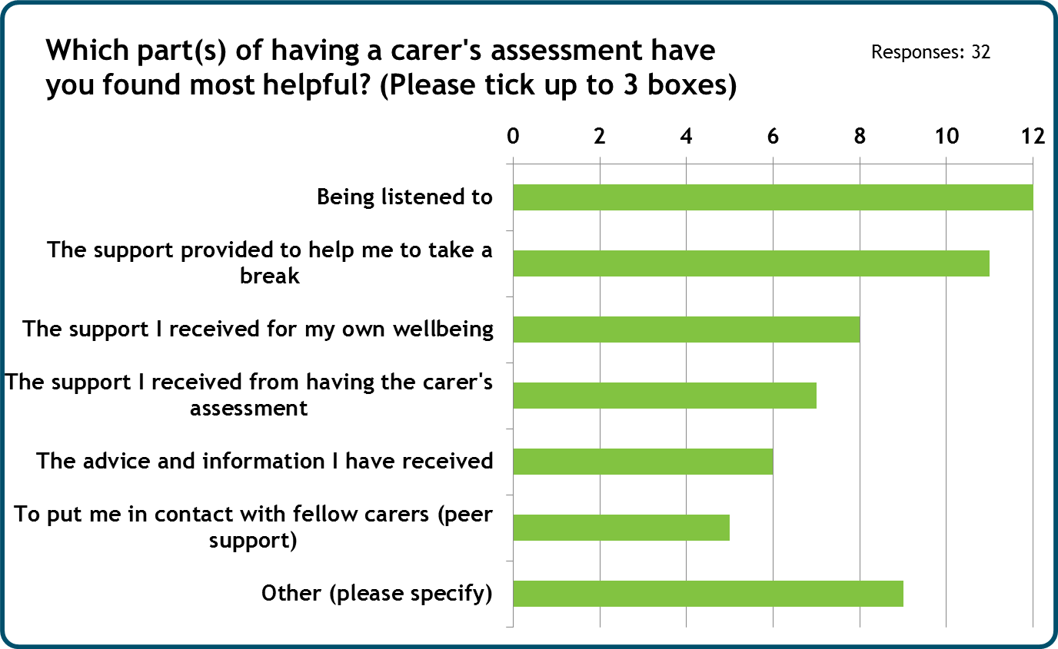

Much of the feedback (as seen on the graph below) indicates that people largely felt that they wanted more information, about the assessment process and the help on offer. It is not surprising that people felt that once an assessment had taken place they wanted a support plan to be implemented.

There was also an issue around people’s concern about the timescales for waiting for an assessment.

# Recommendations

1. **Increase uptake**

* Develop and implement an awareness raising campaign about carer’s assessments and the services available on the Gateshead Council website. Include more information about what people can expect during the carer’s assessment process as well as details of services available for carers.
* Review internal procedures to ensure that people who request an assessment are not refused one (in line with the Care Act 2014). Social workers, and other relevant professionals, should explain about the carer’s assessment process to carers and offer support to complete the forms.

1. **Improve assessment quality**

* Provide carers with information appropriate to their needs (in line with the Accessible Information Standard) before conducting a carer’s assessment in order to help them prepare for the assessment and support full and meaningful discussion.
* Ensure carer’s assessments are conducted in an appropriate timescale and in line with the Care Act 2014.
* Ensure carers receive an annual review.

**3. Streamline partnership working**

* Develop strategies with partners to streamline communication to improve outcomes for carers. The Gateshead Carers Partnership comprises carers, key staff in health, social care and the voluntary sector and strives to give carers a strong strategic voice. Ensure partnership meetings have a regular and accountable representation from Gateshead Council.

# Acknowledgements

We would like to thank the following for their support and involvement in this report:

* Carers throughout Gateshead
* Age UK Gateshead
* Alzheimer’s Society
* Carers Trust Tyne and Wear
* Gateshead Carers Association
* Gateshead Council
* Involve North East
* Newcastle Gateshead Clinical Commission Group
* Stroke Association

# Appendix

**Have you had a carer's assessment in Gateshead?**

A carer's assessment is where someone from Gateshead Council (adults) or the Carers Trust Tyne and Wear (for those under 18) has gone through a series of questions about your circumstances as a carer and what would help you as a carer.

Yes **(please go to section 2)**

No **(please go to section 1)**

Don't know/not sure **(please go to section 1, question 2)**

**Section 1**

**1. Can you tell us why you haven't had a carer's assessment? (Please tick up to 3 boxes)**

Gateshead Council has not offered me a carer's assessment

I don't know about them

I don't consider myself to be a 'carer'

I am concerned about being judged as a carer

I don't think a carer's assessment will help my situation

The criteria to get support is too strict

The waiting times are too long

People who have had one don't recommend them

I don't think I need one

Other (please specify)

**2. What would encourage you to request a carer's assessment? (Please tick up to 3 boxes)**

More information about what a carer's assessment is, and how it can help me

More information about what services are available for carers

That I am offered a carer's assessment

That the carer's assessment happens promptly

That the carer's assessment can happen at a time of my choosing

Other (please specify

**3. Is there anything else you would like to share with us?**

**Please now complete the monitoring information at the end of this survey**

**Section 2**

**1. How did you hear about a carer's assessment?**

Friend or family member

Social worker

Occupational Therapist (OT)

Care worker (also called a domiciliary care worker) who provides help in your home

Gateshead Carers Association

Carers Trust Tyne and Wear (formerly called Crossroads)

Your GP

The internet

Other (please specify)

**2. Did you request a carer's assessment, or was it offered to you?**

I requested one

I was offered one **(Please go to question 6)**

Don't know **(Please go to question 6)**

**3. How would you rate the process you went through to request a carer's assessment?**

Very good

Good

Neither good nor bad

Poor

Very poor

Don't know

**Please can you explain your answer?**

1. **When you initially rang Gateshead Council to request support for yourself (known as Adult Social Care Direct), how would you rate the service you received?**

Very good

Good

Neither good nor poor

Poor

Very poor

Don't know

**5. How long did it take to have a carer's assessment completed once you requested one?**

Within a month

Within 2-3 months

Between 3-6 months

More than 6 months

Don't know

**6. Was the carer's assessment an individual (just for you) or a joint assessment (with the person you care for)?**

Individual

Joint

Don't know

**7. Were you encouraged to take a separate carer’s assessment (just for you)?**

Yes

No

Don’t know

**8. Were you offered a choice of an individual or joint carer's assessment?**

Yes **(please go to Question 10)**

No

Don't know

**9. If you had been offered a choice between an individual carer's assessment (just for you) or a joint carer's assessment (with the person you care for), what would you have chosen?**

Individual

Joint

Don't know

**10. Where you asked about the following areas of your life in your carer's assessment? (Please tick as many boxes as are relevant)**

Physical health

Mental health

Emotional wellbeing

If you wished to stay in or return to employment, education or training

If you want to be caring full time, part-time or to not continue your caring role

Your social situation

Your financial situation

**11. Do you feel that you were listened to during the carer's assessment? (tick one box along the scale 1-5)**

Don’t know

5

Very much

4

3

1

Very little

2

Very poor

**12. Do you feel that your support plan (a document saying what support the Council can offer you) represents your support needs?**

Strongly agree

Agree

Neither agrees nor disagrees

Disagree

Strongly disagree

I never received a support plan

Don't know

**Can you tell us why you have given this answer?**

**13. Please tick which of the following options best reflects what you think of this statement: “Having a carer’s assessment has helped me get the support I need as a carer"**

Strongly agree

Agree

Neither agrees nor disagrees

Disagree

Strongly disagree

Don't know

**14. Which part(s) of having a carer's assessment have you found most helpful? (Please tick up to 3 boxes)**

The advice and information I have received

Being listened to

The support I received from having the carer's assessment

The support I received for my own wellbeing

The support provided to me to help me to take a break

To put me in contact with fellow carers (peer support)

Other (please specify)

**5. What aspect of going through a carer's assessment would you most like to see improved? (Please tick up to 3 boxes**)

|  |  |  |  |
| --- | --- | --- | --- |
|  | Better informed about what a carer's assessment is |  | To not have to wait so long to get my support plan |
|  | Better information about what help is available to me |  | To be offered more support |
|  | Offered a separate carer's assessment (just for me) rather than an assessment conducted with the person I care for |  | That the professional people I spoke to knew more about carer's assessments |
|  | To not have to wait so long for the carer's assessment |  | That I was treated more sensitively during my carer's assessment and the follow up |
|  | That the support identified is provided to me |  | Other (please specify) |
|  | That I received a support plan |  |  |

**Can you tell us why you have given this answer?**

**16. Overall, how would you rate your experience of having a carer's assessment in Gateshead?**

Very good

Good

Neither good nor poor

Poor

Very poor

Don't know

**17. Is there anything else you would like to share with us?**

**18. We would like to have some more in-depth discussions with people about their experiences of care assessments. If you would like to discuss further, by phone or in person, please provide your name and contact details below. All information is confidential and private.**

# 

# **Contact details**

|  |  |
| --- | --- |
|  | Healthwatch Gateshead, Davidson Building  Swan Street, Gateshead, NE8 1BG  NE8 1BG  Gateshead  NE8 1BG |
|  | 0191 477 0033 |
|  | 07535 877 831 |
|  | info@healthwatchgateshead.co.uk |
|  | https://healthwatchgateshead.co.uk |
|  | @HWGateshead  @HWGateshead  @HWGateshead |
|  | gatesheadhealthwatch |
|  | healthwatch_gateshead |

**If you require this report in a different format please call Freephone 0808 801 0382**

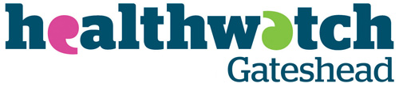Healthwatch Gateshead is part of Tell Us North CIC, company no. 1039496. We use the Healthwatch trademark (which includes the logo and the Healthwatch brand) when carrying out our activities. The Healthwatch logo is a registered trademark and is protected under trademark law.